 **26 Dec 2014** **The Weekly Bulletin of Rotary Club of Kathmandu Mid-Town** **bc-25/12.014**

|  |
| --- |
|  |

District: 3292 Web:www.rotarymidtown.org.np Club Id: 26776

**DECEMBER IS THE FAMILY MONTH**

**Rotarians, clubs, and districts worldwide are encouraged to demonstrate their**

**commitment to family and community through projects, activities, and events in**

**celebration of Family Month each December.**



Wishing you all a Happy New Year 2015

Click here ⇩



Club’s Weekly Meeting # 1259 on Friday, 19 December :

Extracts of the Meeting Minutes are given below:

“1. Meeting No.1259 called to order

“7. A few remarks by the President

“8 A short talk by Mr Tomoo Hozumi on UN/UNICEF on 'FIRST YEARS LAST FOREVER' was introduced by Rtn Deepak. The speaker elaborated on the importance of caring for children especially during the first few years of their lives. The first three years, from conception to about age 2 are known as the 1000 golden days – when much development of the brain takes place. He spoke of the importance of early childhood education and of how cost effective it is. Highlight illustrations from his talk will be available in the next issue of the Breakfast Chatter. PP CK gave the vote of thanks..

“9. Information sharing:

> Program: District The Rotary Foundation Seminar on Date: 27 December 2014 Time: 1:00 PM, Venue: Hotel

Platinum on the date of Hotel Soaltee Crown Plaza, Soaltee mode, Kathmandu, Registration Fees: Rs. 1500.00.

Please confirming/sending in the name(s) of your club's participant(s) as soon as possible. You may send your

confirmation to me or at the Rotary District Office (email: [rotary@ntc.net.np](mailto:rotary@ntc.net.np)  Tel: 016224166/98373897).

> The annual visit of the DG to our Club will take place on 16 Jan 2015. On this occasion the meeting will start at

7:45AM. A special closed session meeting will take place on the previous day in order to give the DG an opportunity

to discuss with the President and to review the Club files. The Chairs please prepare their respective reports.

> Rotary Peace Conference. Leaving Ktm-Lumbini at 5 AM on 07 Feb and returning Lumbini to Ktm at 10 AM on 09

Feb. Rtns can contact PP William Ma. Fares between Rs 3500 to Rs 4000 for the return journey. Please fill out the

form and/or let Mr Dahal know if you are interested in attending.

> PP Komal reported on the Saturday morning walkers' club. Great fun to be had. Pls contact PP Komal for the date

and place of the next walk.

> Rotary District Conference will be held in Chitwan on 26, 27 Feb and 1st March 2015. Pls let Mr Dahal know if you

are interested in attending.

> Please note: 2 Jan - no meeting.

> Past President CK explained that due to poor weather the 18 or so Mid-Towners and guests were thwarted in their

efforts to reach Rara/Mugu. On the other hand, the brave souls who attempted the journey got as far as

and made the best of the situation by taking in some pilgrimage sights in the vicinity. The group wishes to express its

thanks to Rtn Jo of Asian Trekking who kindly arranged for the complementary loan of sleeping bags. Thanks also go

to Rtn Ajay who hosted the entire group at his hotel in Lumbini and also gave them a delicious diner.

> Meeting next week – Dec 26 will be a 'Club Affairs' meeting. Topic TBA.

> Please donate generously to the Rotary Foundation. Donors will be recognised by the DG on his visit.

> PP William informed that Rotracts are hosting a move on Dec 19 at Rims Movie Theatre. Cost: 1000Nrs.

> The President briefed on highlights of the Board Meeting held on Dec 18 2014 as follows:

• The Board felt that because of a number of other conferences being held at the same time it had to refuse the

kind offer on the part of RC Patan West to join them in co-hosting an inter-city meet on 'Light Up Rotary'.

Mid-Towners wishing to join the event are heartily encouraged to do so.

• IPP Saroj and P Komal presented the audited accounts for 2013-14 to the Board. The Board approved these by

acclamation. The signed audited accounts will be circulated to Mid-Towners this week for any additions/

corrections to be discussed next Breakfast meeting (Dec 26 2014).

> Exchange of flags with Rtn Mr Gene Germain (of Manitoba Canada, RC of The Pas, Manitoba Canada 'Home of the

Northern Manitoba Trapper Festival').

> The most recent membership list is being circulated – please let us have your additions/corrections.

“10. Statistics of the meeting: Members present: 22”.

# Weekly Meetings and Programs :

|  |  |  |
| --- | --- | --- |
| Date | Program/Speaker | Topic of Presentation |
| 26 December | Club Affairs Meeting | Discussion on possible and interesting new projects for next year.. |
|  |  |  |
|  |  |  |

**Committee Chairs’ Column:** *(This column is for use by chairpersons of 5 permanent committees: Club Administration, Membership, Public Relations, Service Projects, and the Rotary Foundation)*

**ANM 3-H Grant Project Review - Trip to Rara**

Marking dates, scheduling and rescheduling the trip to Rara/Shirkot for reviewing/closing 3-H Grant ANM (10 districts) project many a time, 12 December Friday was finally set and a group of seven Mid-Towners, 3 family members, Executive Secretary SK Dahal, ex-Midtowner Kailash/spouse, Rtn Uttam Dhungel and Golchha Organization staff Rajaram Joshi/Saroj (project support staff) finally reached Nepalgunj on the day. Everything was in order.

Next day morning, on 13 Dec, as scheduled, the team reached Nepalgunj Airport to take the flight to Rara. Passengers, checked in, and boarding pass given, and waiting for the final call to board the aircraft, were surprised to get the message of flight cancellation due bad weather. Back to hotel, the team kept constant contact with airline officials to find out flight status for the next day. They themselves engaged in finding weather conditions in and around Rara.

Next day on 14 Dec, the team upon getting information from the airline authorities that the flight to Mugu was uncertain for Mugu airport became unserviceable due heavy snowfall, decided to visit Sworgadwari in Piuthan amidst other options of visiting Lucknow, Karnali bridge etc were also discussed.

On 15 Dec Monday, on the way down from Sworgadwari, the team, while contacting the airline officials, got the message that the flight to Mugu was still uncertain because of more snowing in and around. The team decided to cancel the program of visiting Rara/Shirkot and to return Kathmandu.

Accordingly, the team returned to Kathmandu on Tuesday, 16 December by Bhairawa-Kathmandu flight.

**South Asia Conference on Peace: 6-9 Feb 2015**

RI District 3292 - Nepal/Bhutan is organising 'Rotary South Asia Conference on Peace' during 6-9 February 2015

in Lumbini, the birth place of Lord Gautam Buddha, the ***Light of Asia***.

The Ministry of Peace and Reconstruction, the Ministry of Culture, Tourism and Civil Aviation and

the Ministry of Cooperatives and Poverty Alleviation are co-organizing this event.

Selected themes for the Conference are:

"Fountain of Peace", "Peace and Conflict Prevention and Resolution",

"Role of UN in Peace Building in South Asia", "Peace and Poverty Alleviation in South Asia",

"Peace and Tourism Development in South Asia", "Youth as Builders of Peace," and

"Role of SAARC on Peace in South Asia"

**Inter-City Meeting**

RI District 3292 is organizing an Inter-City Meeting (ICM) on RI theme

**"Light up Rotary"**

on 23 February 2015 (Monday) in Kathmandu to celebrate World Understanding and Peace Day.

**Fast 8 Days a Year, Boost Immunity:**

For those who hate fasting, starving for just eight days a year can bolster your immune system like never before. Fasting encourages body to replace old and damaged cells – especially if the immune system has been damaged by aging or cancer treatment, researchers said.

“When you starve, the system tries to save energy, and one of the things it can do to save energy is to recycle a lot of the immune cells that are not needed, especially those that may be damaged,” explained Valter Longo, a longevity expert from University of Southern California.

During the study, the researchers found fasting for two to four days every six months forced the body into survival mode – using up stores of fat and sugar and breaking down old cells. The body then sent a signal telling stem cells to regenerate and rebuild the entire system.

“With a system heavily damaged by chemotherapy or aging, fasting cycles can generate, literally, a new immune system,” Longo noted.

In lab settings, fasting also reduced ill effects and death in mice exposed to chemotherapy drugs and boosted immunity in aging mice.

“The results suggest that fasting may mitigate some of the harmful effects of chemotherapy,” added Tanya Dorff, a co-author of the research published in the journal Cell Stem Cell.

*Source: The Himalayan Times*

**Members’ Corner:** *(This column is for Club members to express anything they would like in matter of Club activities, Club administration, Club issues or on Breakfast Chatter, or on anything else that would be of interest to fellow members.)*

Travel and Tourism

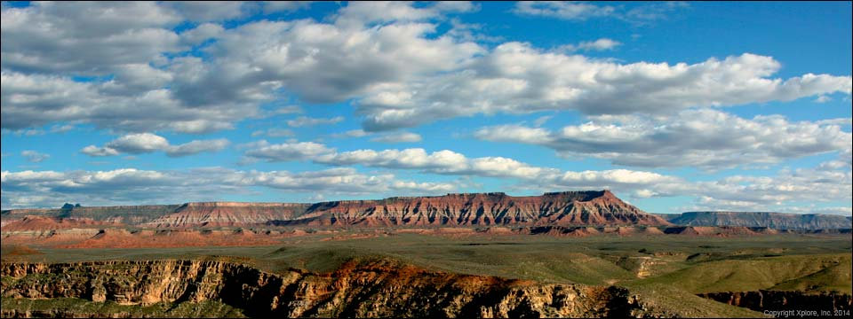

.*Source: Internet*

**A THOUGHT FOR TODAY:**

**You cannot shake hands with a clenched fist.**

- Indira Gandhi, prime minister of India (1917-1984)

*Courtesy: Rtn Isabella Khadka*





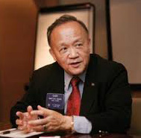

Our job is to make the news in the world a little better — a little happier, a little more

hopeful. It’s our job to make the good news. And it’s also our job to get the good news on

the news!

**RI President GARY C.K. HUANG**

Please send information on club activities, progress reviews on service projects, relevant photos etc to:

BC Editor: RR Shrestha email: rryesrr@gmail.com

## 26 December 2014 The Weekly Bulletin of Rotary Club of Kathmandu Mid-Town bc-25/12.014

*******************************